To whom it may concern:

Allschwil, February 2025

CONFIRMATION LETTER for

Ms. Zenabu SUBOI
DOB: 02.11.1991

Rent in Biel Benken: Löliring 33, 4105 Biel Benken

Dear Madam, dear Sir

This letter is a confirmation that Ms. Suboi will be accommodate in
Löliring 33, 4105 Biel Benken

Her rent will Start 01. February – 31. December 2025

Her rent will be paid by her scholarship.

CHF 730.--


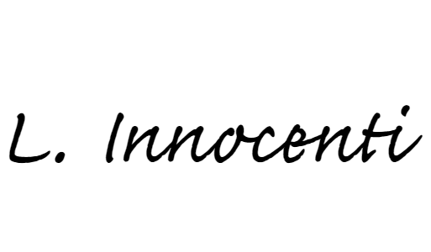
Yours sincerely

Laura Innocenti

